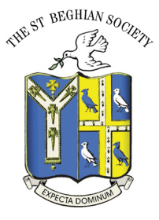

Scottish Branch
Notice of Reunion Dinner 2016

Dear Fellow St Beghian,

This year’s reunion dinner will be held on Friday 25th November at the Royal Scots Club in Edinburgh. It is hoped that Mark George, Vice Chair of the new St Bees School Trustees will be able to attend to give us an update on developments. Our President, Dacre Watson will be joining us and will provide some insight on matters happening within the St Beghian Society.
The reunion dinners of the last few years have been better attended but it is hoped that even more will turn out this year. You are warmly invited to join us and help make it an evening of good companionship and bon homie.
The work in maintaining the school’s fabric continues and a peep at the Society’s and Board of Trustees’ Newsletters highlight the progress that is being made to protect the school for any future reawakening.
Do come along and join us. The message is very clear that the St Beghian Society is active and still provides a strong link for former pupils across the UK and Overseas.

Date : Friday 25th November 2016

Venue : Royal Scots Club , Edinburgh

Cost : £37.50 per head

Time : Meet in lounge bar 7 for 7.30pm – meal served 8.15pm

Accommodation : Rooms are available at the Club and you are asked to contact them direct. www.royalscotsclub.co.uk

Payment : Cheques made payable to David M Parker (OSB Scotland Dinner’16) and sent to address as shown below.

Many thanks,
David Parker (G 63-68).

Bromview Cottage, Ardcharnich , Loch Broom , Nr Ullapool , Ross-Shire. IV23 2RQ.
Tel: 01854 655300 or email parkyatdeanst@yahoo.co.uk.

